1 | JDK | 1.8 | https://www.oracle.com/in/java/technologies/javase/javase8-archive-downloads.html
2 | JRE | 1.8 | https://www.oracle.com/in/java/technologies/javase/javase8-archive-downloads.html
3 | Android Studio | 2021.3.1 | https://developer.android.com/studio
4 | NodeJS | 18.12.1 | https://nodejs.org/en/download/
5 | Appium | 1.22.3 | npm install -g appium
6 | Appium Server Gui | 1.22.3-4 | https://github.com/appium/appium-desktop/releases/tag/v1.22.3-4
7 | Appium Inspector | 2022.11.1 | https://github.com/appium/appium-inspector/releases
8 | Intellij | 2022.2.1) | https://www.jetbrains.com/idea/download/#section=windows
9 | Apache Maven | 3.8.6 | https://maven.apache.org/download.cgi

- Download Java from the given URL
  - Double Click the downloaded file to start the installation
  - After running the installation file, the installation wizard screen appears
  - 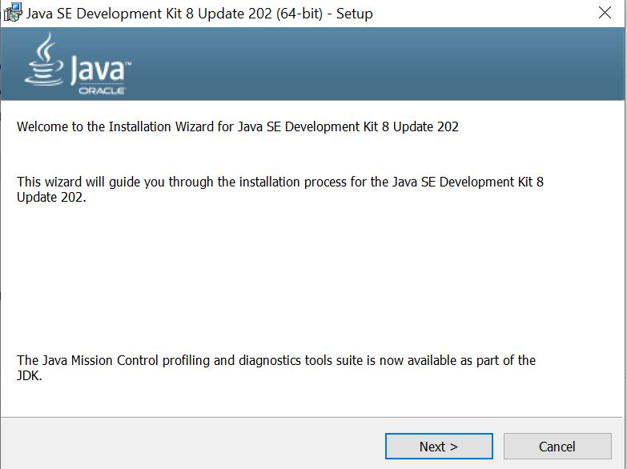
  - Choose the destination folder for the java installation files or stick to default path. Click next to proceed.
  - 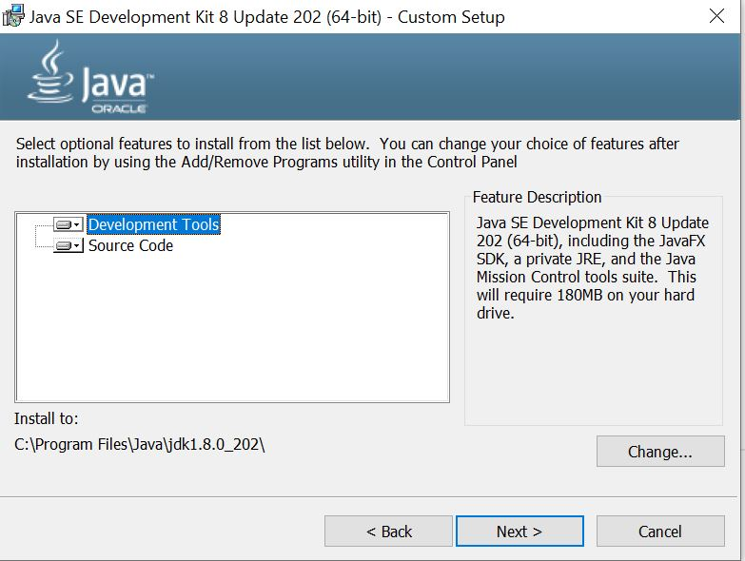
  - Wait for the wizard to finish the installation process until the Successfully Installed message appears. Click Close to exit the wizard

  - 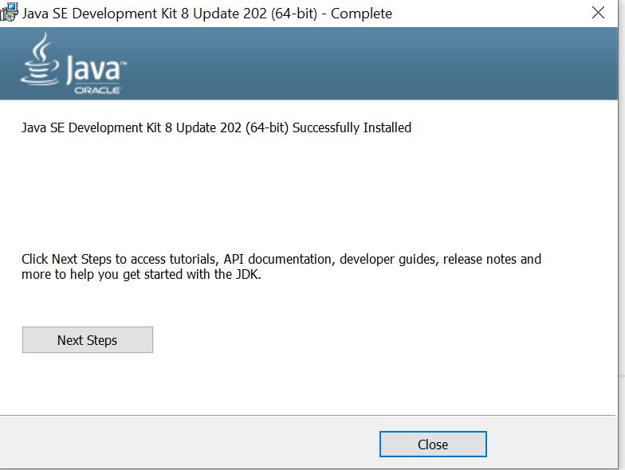

  - Set the environment variables.

    - Open the Start menu and search for environment variables.
    - Select the Edit the system environment variables result.
    - 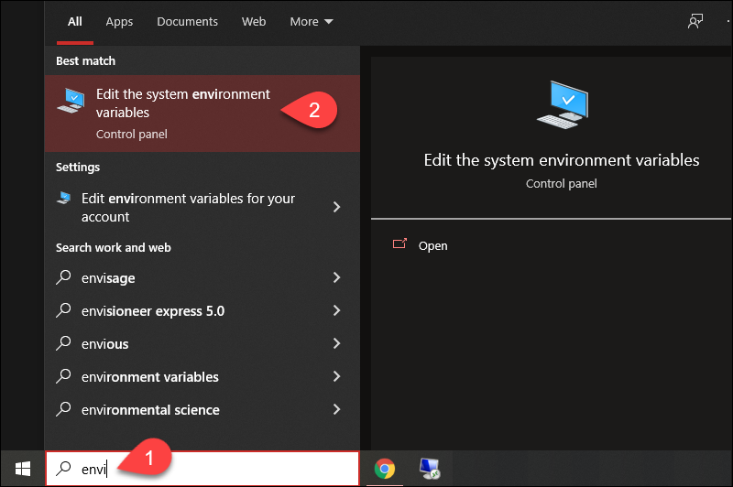
    - In the System Properties window, under the Advanced tab, click Environment Variables…
    - 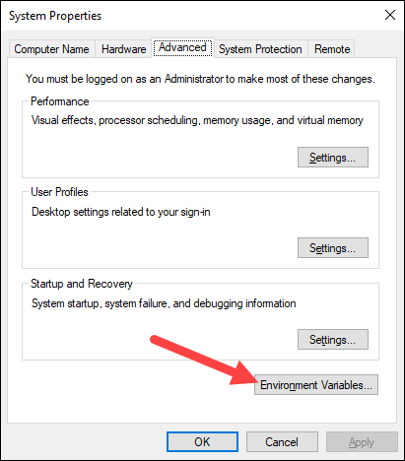
    - Under the System variables category, select the Path variable and click Edit:
    - 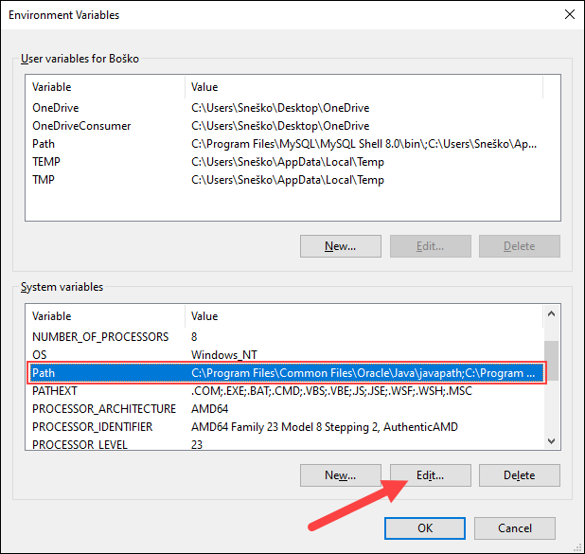
    - Click the New button and enter the path to the Java bin directory:
    - 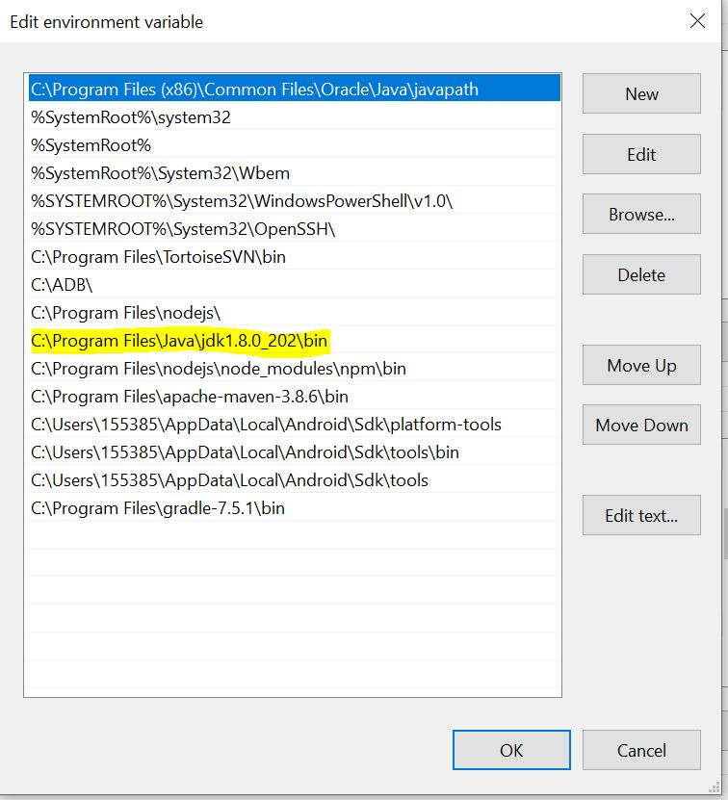
    - In the Environment Variables window, under the System variables category, click the New… button to create a new variable.

    - 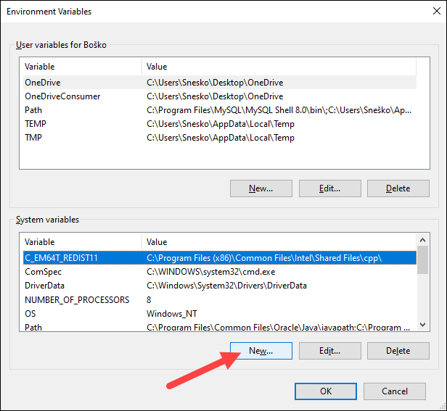
    - Name the variable as JAVA_HOME.
    - In the variable value field, paste the path to your Java jdk directory and click OK.
    - 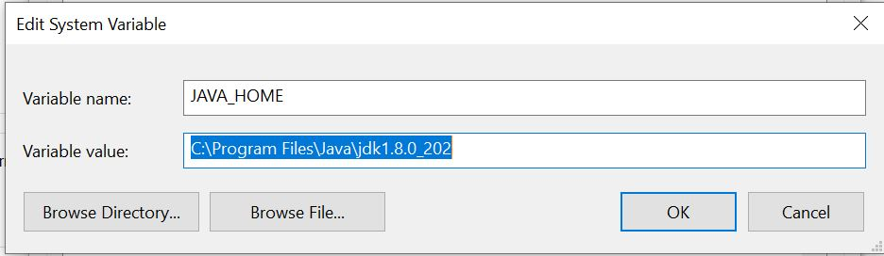
    - Confirm the changes by clicking OK in the Environment Variables and System properties windows.
    - Run the java -version command in the command prompt to make sure Java installed correctly:
    - 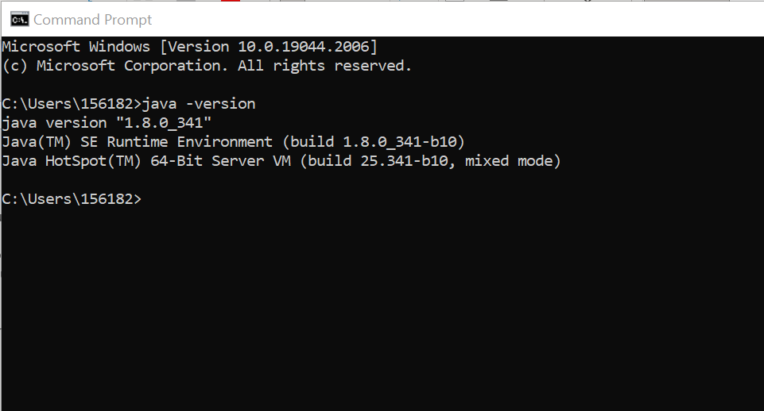

- Install JRE from the given link
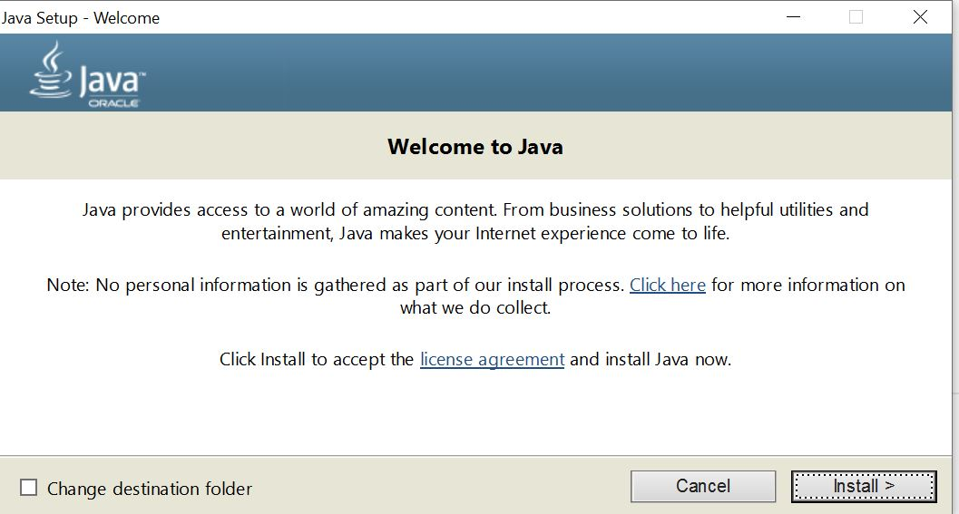

- Download Android Studio (SDK) from the given link.
3.1 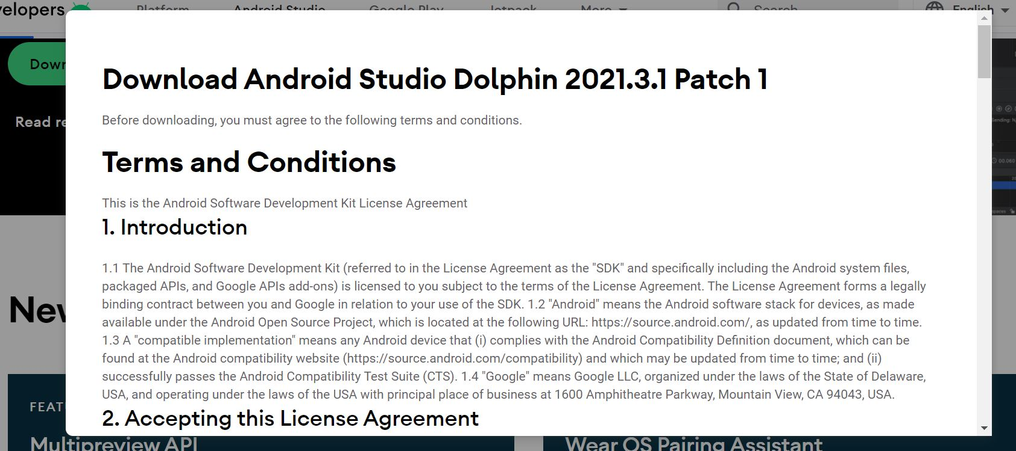
3.2 Double Click the downloaded file to start the installation
3.3 Click Next and click on Install button.
    - Open the Start menu and search for environment variables.
    - Select the Edit the system environment variables result.

    - In the System Properties window, under the Advanced tab, click Environment Variables…

    - Under the System variables category, select the Path variable and click Edit:

    - Click the New button and enter the path to the Java bin directory:
    - 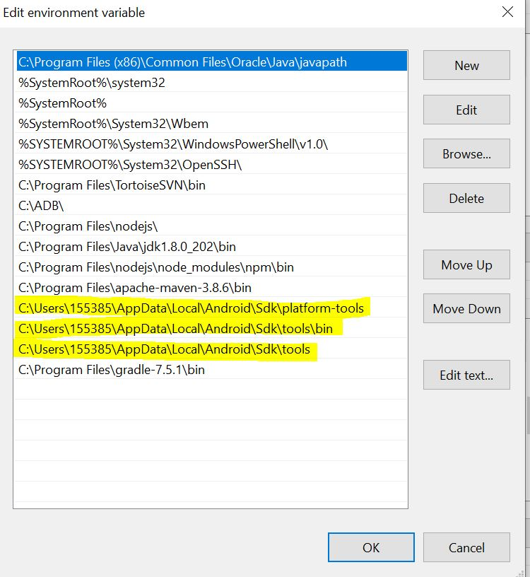
    - In the Environment Variables window, under the System variables category, click the New… button to create a new variable.
    - Name the variable as ANDROID_HOME.
    - In the variable value field, paste the path to your Android sdk directory and click OK.
    - d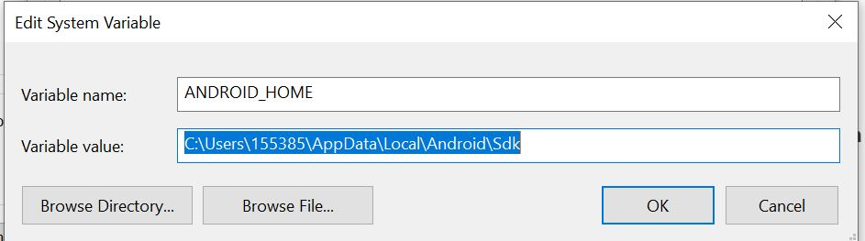
    - Confirm the changes by clicking OK in the Environment Variables and System properties windows.

- Download the Node.js ‘.msi’ installer from the given URL.
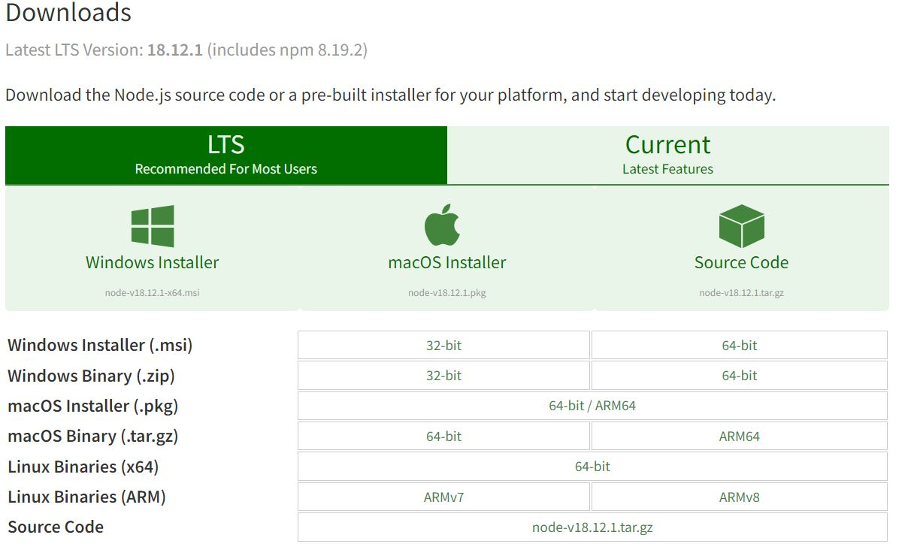
  - Double click on the .msi installer.
  - 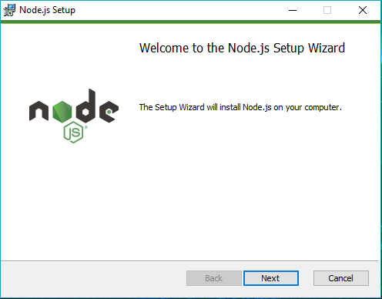
  - Check “I accept the terms in the License Agreement”
  - Select “Next”
  - 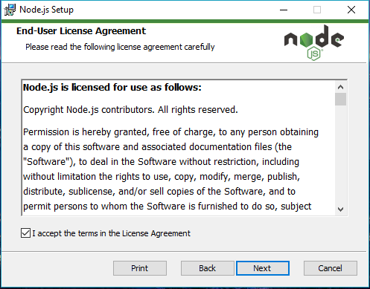
  - Set the Destination Folder where you want to install Node.js & Select “Next”
  - 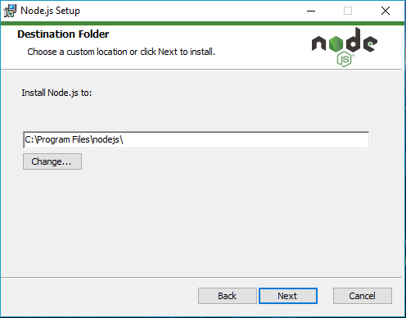
  - Select “Next”
  - 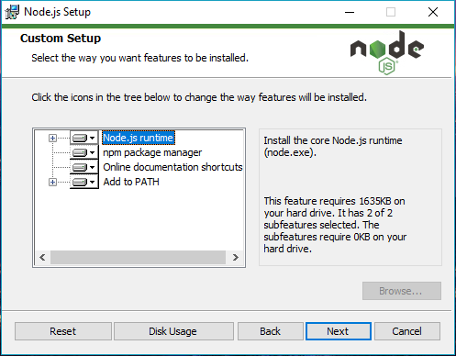
  - Select Install
  - 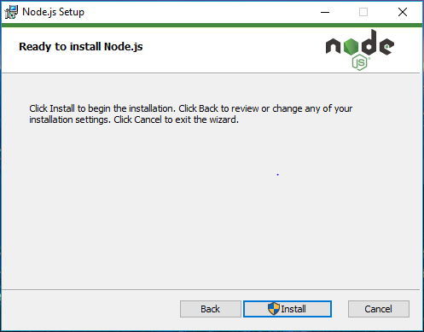
  - Click Finish
  - 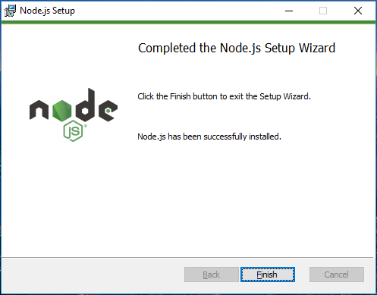
  - Verify that Node.js was properly installed or not.
  - 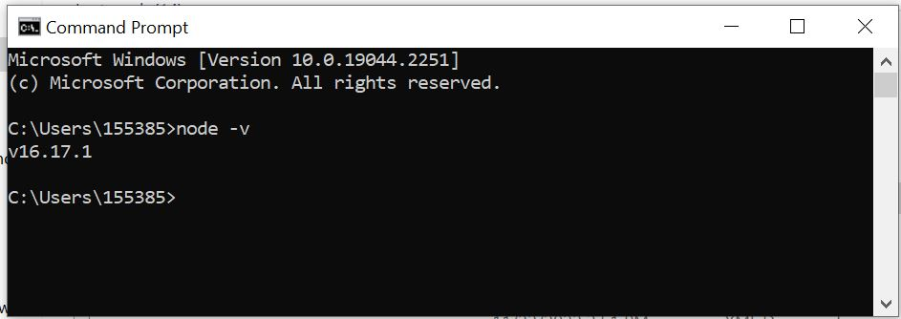

- Install Appium
  - Start the command prompt as an administrator
  - Run the following command
  - npm install -g Appium
  - 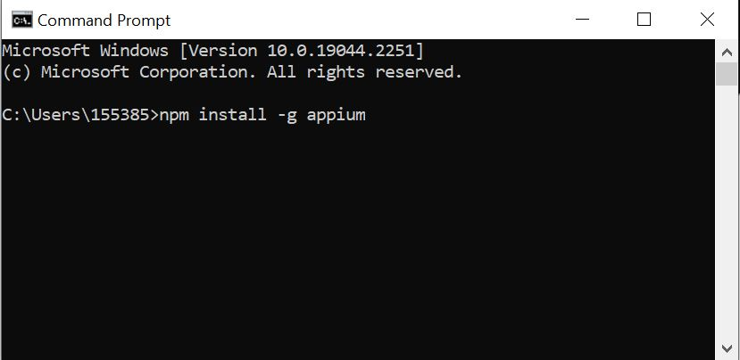
  - Verify Appium installed or not
  - 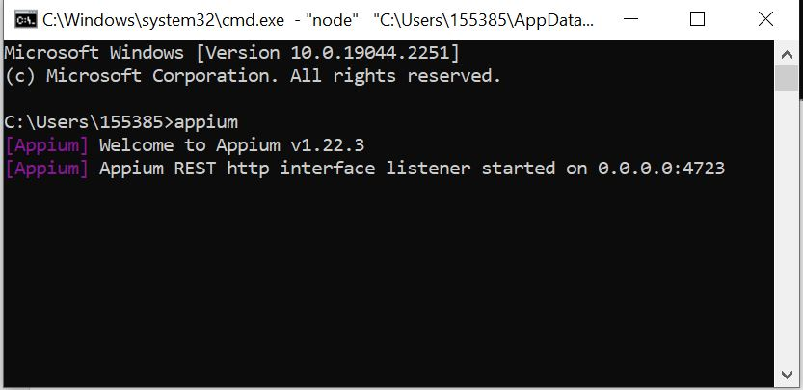

- Download Appium Server GUI from the given link
  - 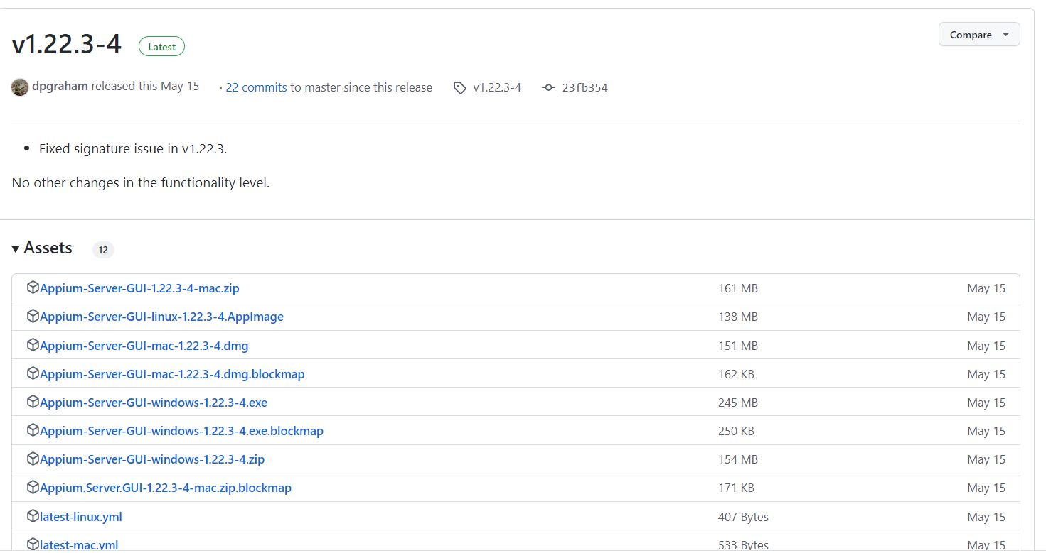
  - Double click on the downloaded file
  - Click Install
  - 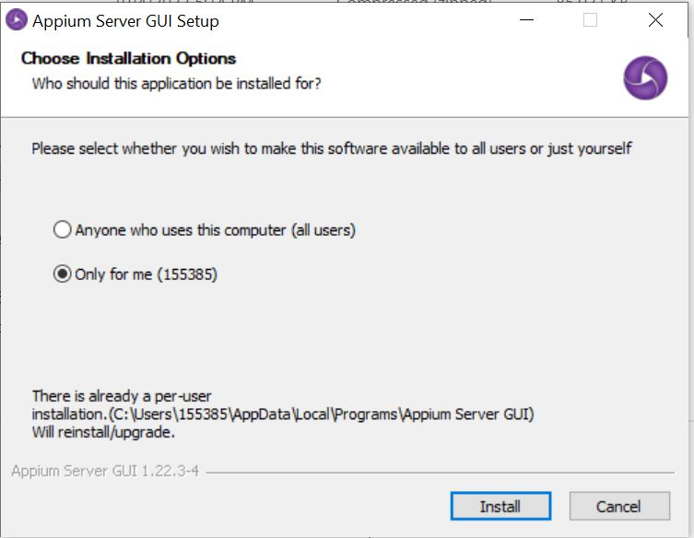
  - Verify Appium Server is Installed or not
  - 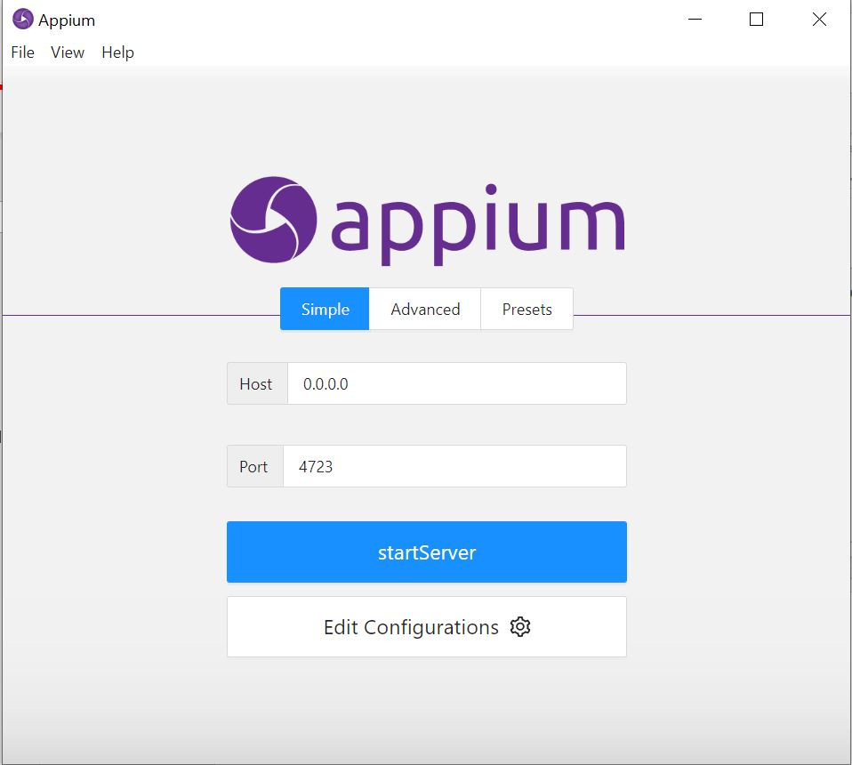

- Download Appium Inspector from the given link
  - Double click on the downloaded file.
  - Install the Appium Inspector
  - 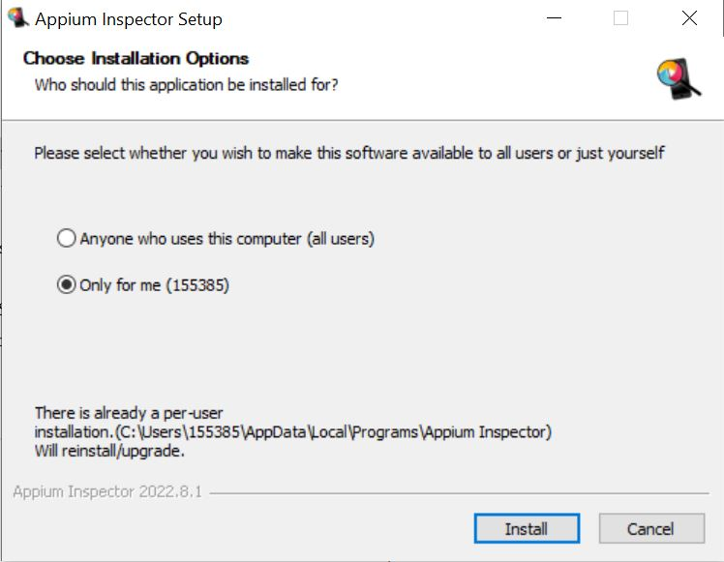
  - Verify the appium Inspector
  - 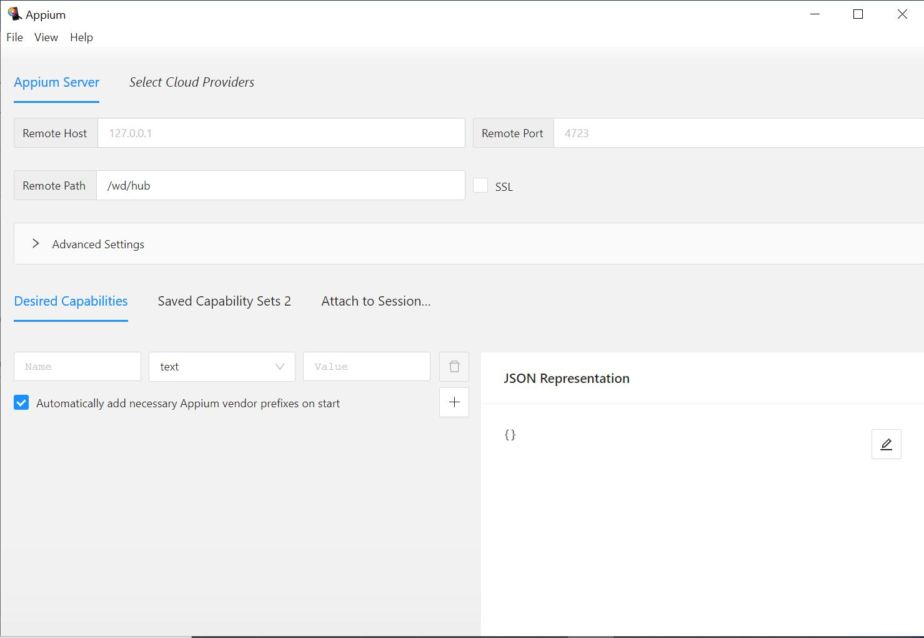

- Downloaded eclipse from the given URL
  - Double click on downloaded file
  - Click Install
  - Select Import option from the file
  - Select existing Maven Project
  - 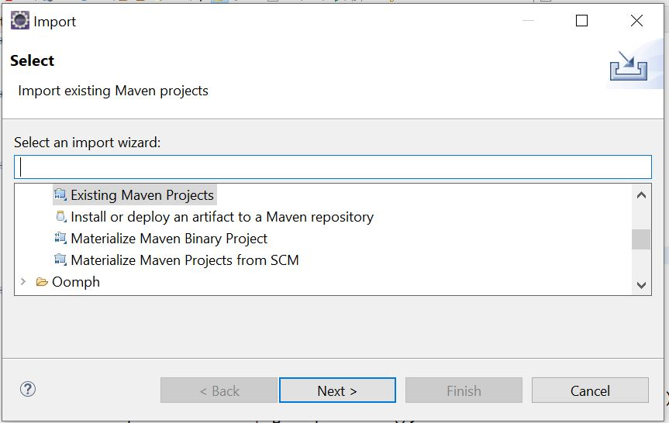
  - Click Next
  - Browse the project
  - 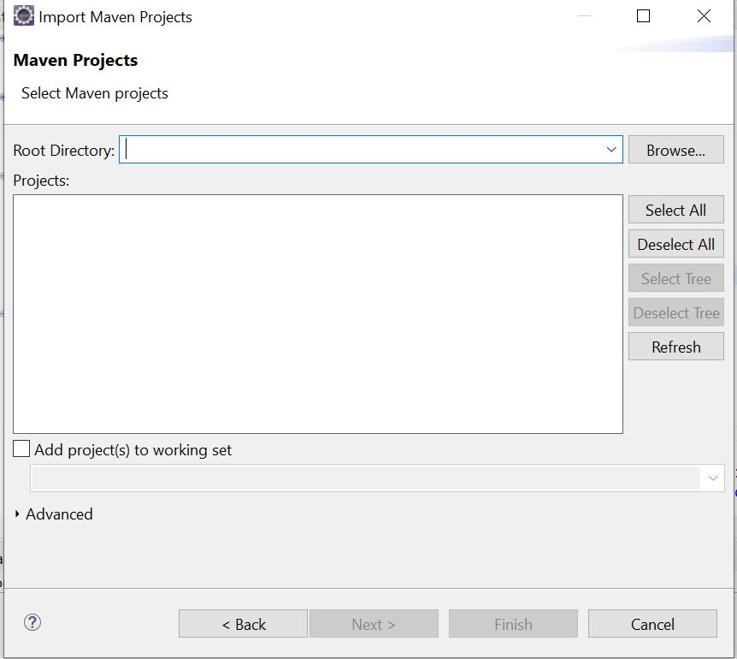
  - Select the folder project and click on import
  - 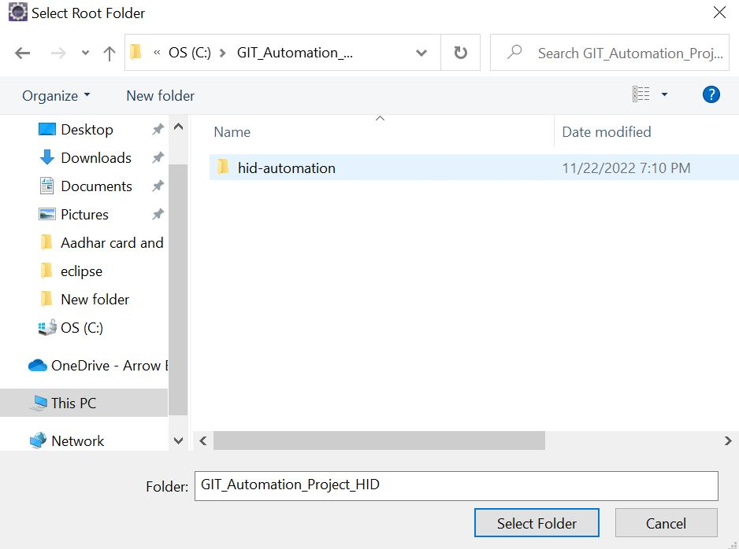

- Download Maven zip file from the given URL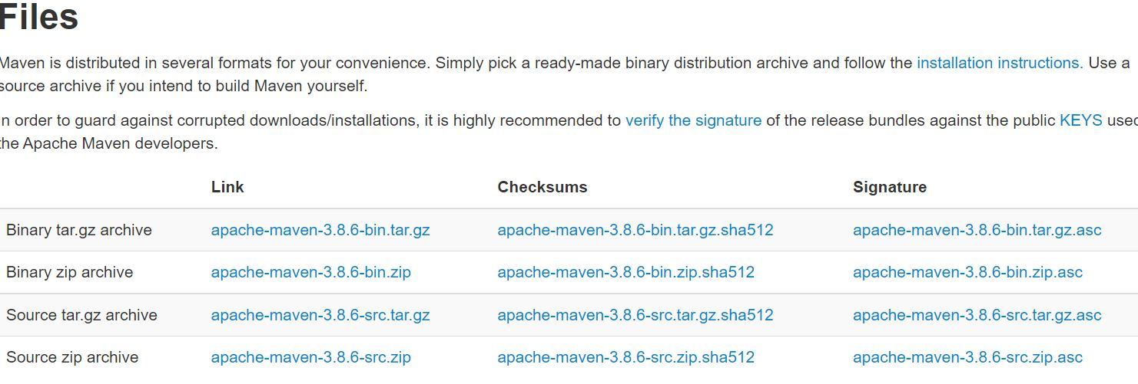
  - Extract the downloaded zip file and place that into program file in the c drive.
  - Set the system variables
    - Open the Start menu and search for environment variables.
    - Select the Edit the system environment variables result.
    - In the System Properties window, under the Advanced tab, click Environment Variables…
    - Under the System variables category, select the Path variable and click Edit:
    - Click the New button and enter the path to the Java bin directory:
    - 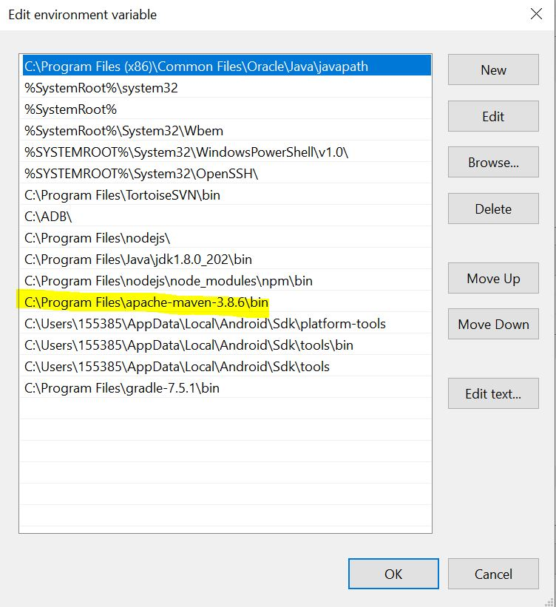
    - Verify Maven using command mvn -v
    - 